|  |  |  |
| --- | --- | --- |
| **Tech Saksham**  Final Project Report  **TRACK1_APPLIED_CC_FOR_SOFTWARE_DEVELOPMENT** |  |  |

**“LIBRARY MANAGEMENT SYSTEM”**

**“RAYALASEEMA UNIVERSITY COLLEGE OF ENGINEERING”**

**KURNOOL**

|  |  |
| --- | --- |
| **ROLL NO** | **NAME** |
| **20RU1A0543** | **PRAKASH GARI CHAITHRA** |
| **20RU1A0450** | **RAMIREDDY GARI SAI KEERTHANA REDDY** |
| **20RU1A0560** | **YARAVA VENKATASUBBA REDDY** |

|  |  |
| --- | --- |
|  |  |
|  | **Hrishikesh Mahure** |
|  | Master Trainer  Edunet foundation |

**ABSTRACT**

In today's digital age, libraries remain a vital hub of knowledge dissemination and academic research. To meet the evolving needs of patrons and librarians alike, the Library Management System (LMS) emerges as an indispensable tool. This abstract provides an overview of our LMS, a robust and user-friendly software solution designed to enhance the efficiency and effectiveness of library operations.

Easily manage and update the library's collection, including books, journals, multimedia, and digital resources. Automated cataloging, categorization, and metadata management simplify this crucial task

Our Library Management System aims to transform libraries into dynamic information hubs that adapt to the evolving needs of the digital era. Whether in academic institutions, public libraries, or specialized collections, this system promises to revolutionize how libraries operate, making knowledge more accessible and enhancing the overall library experience.

Streamline membership registration, track patron activity, and provide personalized services. The system also facilitates overdue item notifications and fine management. Implement an intuitive and efficient process for borrowing and returning items, reducing wait times and enhancing user satisfaction. Empower patrons to search, reserve, and renew items online. Customizable search options and user-friendly interfaces ensure a seamless experience.

Utilize RFID or barcode technology to efficiently track the movement of items within the library, reducing theft and loss. Simplify the procurement process with tools for budget allocation, vendor management, and purchase order generation.Generate insightful reports on library usage, collection trends, and patron behavior to make informed decisions. Seamlessly integrate with other library systems, university databases, or digital repositories to enhance resource discovery.

This abstract provides a brief but informative overview of the Library Management System's features and benefits, highlighting its role in modernizing library operations and enhancing user satisfaction.

**ACKNOWLEDGEMENT**

It is my privilege and pleasure to express my profound sense of respect,gratitude and indebtedness to my guide, Mr. Hrishikesh Mahure, for his indefatigable inspiration,guidance, cogent discussion and encouragement throughout this dissertation work.

Iam grateful to Mr. V.Satish Kumar, M.Tech Coordinator of Computer Science and Engineering for his support and uninterrupted cooperation during my projectwork.

I am deeply indebted to my Principal Dr.Y. Hariprasad Reddy, M..Tech, Ph.D for his constant support and valuable guidance was a source of inspiration for me.This Acknowledgement will be incomplete without mentioning my sincere gratefulness to our Honorable Vice Chancellor Prof. A.Ananda Rao Garu, who has been observed posing valiance in abundance, forwarding my individuality to acknowledge my project work tendentiously.

Last but not least, I wish to acknowledge myfriends, family members and colleagues for giving moral strength and helping me to complete this dissertation .

Thankyou.

Sincerely,

p.chaithra-20RU1A0543

R.sai keerthana-20RU1A0450

Y.venkatasubba reddy-20RU1A0560

**INDEX**

|  |  |  |
| --- | --- | --- |
| **Sr. No.** | **Table of Contents** | **Page No.** |
| 1 | Chapter 1: Introduction | 1-4 |
| 2 | Chapter 2: Services and Tools Required | 5-16 |
| 3 | Chapter 3: Project Architecture | 17 |
| 4 | Chapter 4: Architecture Blocks Detail Working | 18-19 |
| 5 | Conclusion | 20 |
| 6 | References | 21-22 |
| 7 | Code | 23 |

**CHAPTER 1**

**INTRODUCTION**

* 1. **Overview**

A Library Management System (LMS) is a software solution designed to automate and streamline various tasks and processes within a library. It serves as a central tool for efficiently managing library resources, providing services to patrons, and maintaining an organized and accessible catalog. Here is an overview of the key components and functions of a Library Management System

* 1. **Feature**

A Library Management System (LMS) includes a wide range of features and functionalities designed to streamline library operations and enhance user services.

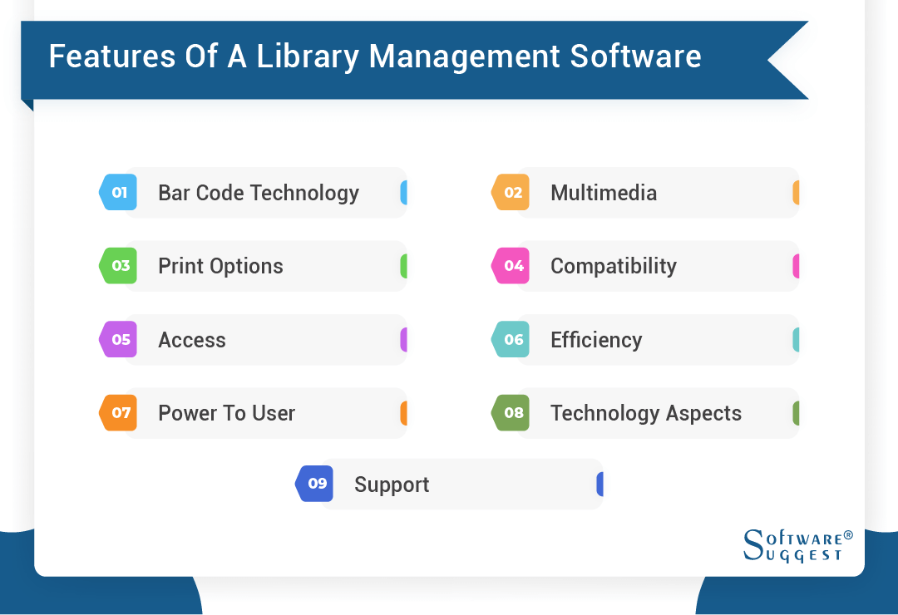

**1.3Advantages**

A Library Management System (LMS) offers numerous advantages for libraries and organizations that manage large collections of books and other materials. Here are some of the key advantages of using a Library Management System:

1. **Efficient Cataloging:** LMS allows for the systematic cataloging and classification of library resources, making it easier for users to find the materials they need. It helps in maintaining accurate records of items in the collection.
2. **Improved Accessibility:** Users can search for books and other materials online, check availability, and place holds or requests for items, enhancing the accessibility and convenience for library patrons.
3. **Inventory Management:** LMS enables efficient tracking of books and other materials, including acquisition, circulation, and inventory management. It helps in reducing the chances of lost or misplaced items.
4. **Automation:** Many routine tasks, such as issuing and returning books, fine calculation, and overdue reminders, can be automated through an LMS, reducing the workload on library staff and ensuring accuracy.
5. **Digital Resources:** Modern LMS systems can manage digital resources, including e-books, e-journals, and multimedia materials, making them easily accessible to users.
6. **Data Security:** LMS systems provide data security features to protect sensitive patron information, circulation records, and other library data.
7. **Analytics and Reporting:** LMS generates reports and analytics on library usage, helping librarians make informed decisions about resource allocation and collection development.
8. **User Management:** LMS allows libraries to maintain user accounts, track user borrowing history, and personalize user services, such as recommending books based on past borrowing behavior.
9. **Interlibrary Loan:** It facilitates interlibrary loan services by connecting with other libraries' systems, making it easier for patrons to access materials not available in their library.
10. **Cost Savings:** LMS reduces the need for manual record-keeping and paperwork, which can lead to cost savings in terms of staff time and resources.
11. **Online Reservations and Renewals:** Patrons can reserve books and renew them online, enhancing user convenience and reducing the need for physical visits to the library.
12. **Integration:** LMS systems can integrate with other library technologies, such as RFID systems, self-checkout machines, and online payment gateways, streamlining library operations.
13. **Accessibility Compliance:** Many LMS systems are designed to comply with accessibility standards, ensuring that library services are available to all users, including those with disabilities.
14. **Scalability:** Libraries can expand their collections and services easily with a scalable LMS, accommodating growth and changes in user needs.
15. **Remote Access:** Users can access digital resources and services remotely, which is especially valuable during circumstances like lockdowns or for distance learners.
16. **Enhanced User Experience:** LMS systems often come with user-friendly interfaces and search features that enhance the overall user experience, making it easier for patrons to find and borrow materials.
17. **Community Engagement:** Some LMS systems support community engagement features like discussion forums, book reviews, and event calendars, fostering a sense of community among library users.

In summary, a Library Management System streamlines library operations, enhances user services, and improves overall efficiency and effectiveness in managing library collections, making it an essential tool for modern libraries and information organizations.

Top of Form

Regenerate

* 1. **Scope**

In this sub chapter, project scope will carried out what modules were contains inside the Library Management System.

For Library Management System, it is divided into online web site and library system. For my part, I was responsible for library system while the online web site was carried out by my friend Koh Yee Keat.

At here, I will describe my own part which is library system which used by librarian.

**1.4 Future Work**

The future of Library Management Systems (LMS) is likely to see significant advancements driven by technology and changing user expectations.

The future of Library Management Systems will be shaped by the evolving needs of library users, advancements in technology, and the broader trends in the information and education sectors. Adapting to these changes and embracing innovative solutions will be key for libraries to remain relevant and effective in the digital age.

**CHAPTER 2**

**SERVICES AND TOOLS REQUIRED**

**2.1 Services Used**

A Library Management System (LMS) is a software application or system used by libraries to manage their resources, automate various tasks, and provide services to library patrons efficiently. Here are some of the key services and features commonly used in a Library Management System:

1. Cataloging and Classification:

Cataloging: Creating and maintaining records of library materials (books, DVDs, journals, etc.) including details like title, author, publication date, and subject.

Classification: Organizing materials into categories or subject areas using systems like Dewey Decimal Classification or Library of Congress Classification.

2. Circulation Services:

Check-In/Check-Out: Managing the borrowing and returning of library materials, including due date tracking and fines calculation.

Reservations: Allowing patrons to reserve items that are currently checked out.

3. Patron Management:

User Registration: Creating and managing patron accounts with personal information and borrowing history.

User Authentication: Ensuring secure access to patron accounts and sensitive information.

4. Inventory Management:

• Item Inventory: Tracking the availability and location of library materials.

• Stock Management: Managing inventory levels and ordering new materials when needed.

• Weeding: Identifying and removing outdated or damaged materials from the collection.

5. Search and Discovery:

• Online Catalog: Providing a user-friendly interface for patrons to search and locate library materials.

• Search Filters: Allowing patrons to refine searches by various criteria such as author, title, subject, and format.

• Recommendation Systems: Offering personalized book recommendations based on patron preferences and borrowing history.

6. Interlibrary Loan: Facilitating the borrowing of materials from other libraries on behalf of patrons.

7. Digital Resource Management:

• E-books and E-journals: Managing and providing access to digital resources.

• Digital Lending: Allowing patrons to borrow and access digital materials.

8. Reporting and Analytics:

Generating reports on library usage, circulation statistics, and collection analysis to make informed decisions.

9. Communication:

• reservations, and other relevant information.

• Messaging: Enabling patrons to contact library staff for assistance or inquiries.

10. Administration and Staff Tools:

• Staff Interfaces: Providing staff with tools for cataloging, circulation, and user management.

• Access Control: Managing staff permissions and access levels within the system.

• Backup and Data Recovery: Ensuring data integrity and availability.

11. Security and Privacy: Implementing measures to protect patron data and ensure data privacy and security.

12. Integration with other systems: Integrating with other library systems, such as RFID systems for inventory management, and with external databases or digital repositories.

13. Accessibility and User Experience: Ensuring the system is user-friendly and accessible to all patrons, including those with disabilities.

14. Mobile Apps and Online Services: Offering mobile apps and online access for patrons to search the catalog, renew items, and access digital resources remotely.

15. Self-Service Options: Providing self-service kiosks for check-in/out and online account management.

A Library Management System streamlines the operations of a library, making it easier for patrons to access and use library materials while also helping library staff manage their resources efficiently. The specific features and services offered may vary depending on the software used and the needs of the library.

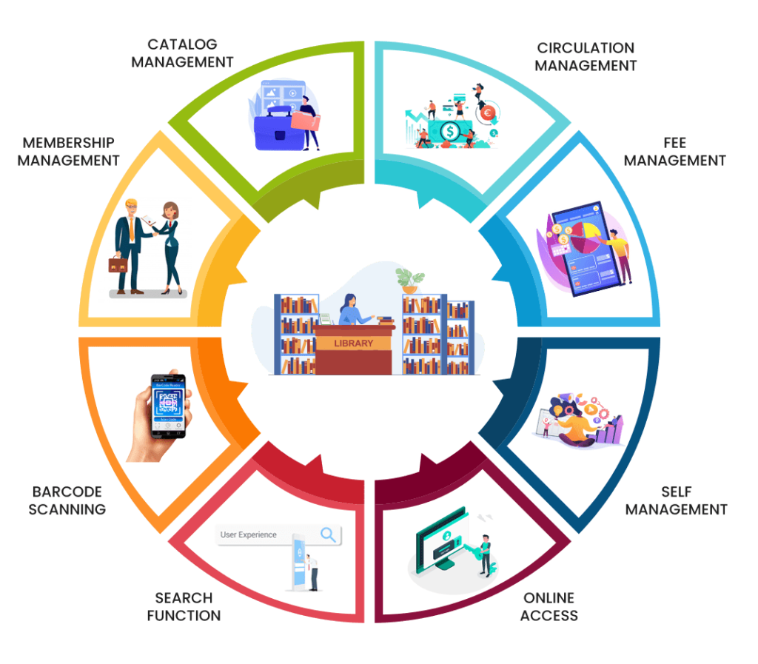

**2.1.1 Liberty Profile**

The term "Liberty Profile" in the context of a Library Management System (LMS) doesn't appear to have a direct association. However, it's possible that you are referring to something specific related to the LMS or a component or technology used within the LMS.

Here are a couple of possibilities:

1. IBM WebSphere Application Server Liberty Profile: Liberty Profile is a lightweight and flexible application server offered by IBM as part of their WebSphere Application Server product family. It's designed to be a more lightweight and modular alternative to the full WebSphere Application Server. While it might not be directly related to the core functions of a Library Management System, it could be used as the underlying application server for hosting the LMS software.

2. Customization or Module Named "Liberty Profile": In some cases, library systems are highly customizable, and libraries or software developers might create custom modules or features within the LMS and give them specific names. "Liberty Profile" could be a custom module or feature designed to provide certain functionalities or services tailored to the needs of a specific library.

If you have more context or details about how "Liberty Profile" relates to your Library Management System, please provide additional information, and I'd be happy to provide a more specific answer.

**2.2 Tools and Softwares used**

Library Management Systems (LMS) utilize a variety of tools and software components to manage library resources and provide services to patrons efficiently. Below are some common types of tools and software used in LMS:

1. **Integrated Library Systems (ILS):** ILS is the core software used in libraries to manage various functions like cataloging, circulation, acquisitions, and more. Common ILS software includes:
   * Koha
   * Evergreen
   * SirsiDynix Symphony
   * Ex Libris Alma
   * Innovative Interfaces Sierra
2. **Discovery Layers:** These tools provide patrons with user-friendly search interfaces to discover and access library resources. They often integrate with ILS. Examples include:
   * EBSCO Discovery Service
   * Primo by Ex Libris
   * Summon by ProQuest
3. **Digital Asset Management (DAM) Systems:** For managing and providing access to digital resources, libraries use DAM systems, which may include:
   * CONTENTdm
   * Islandora
   * DSpace
   * Fedora Commons
4. **RFID Systems:** RFID technology is used for efficient circulation and inventory management in libraries. This includes RFID tags, readers, and software for integration with the LMS.
5. **OpenURL Resolvers:** These tools help patrons access full-text content when searching for articles and e-resources. Common resolvers include SFX and 360 Link.
6. **Interlibrary Loan (ILL) Software:** To facilitate borrowing materials from other libraries, libraries use ILL software like ILLiad and Relais International.
7. **Proxy Servers and Authentication Systems:** These tools ensure remote access to library resources by authenticating and authorizing users. EZproxy is a common tool for this purpose.
8. **Content Management Systems (CMS):** For managing library websites and digital content, CMS platforms like WordPress, Drupal, and Joomla are often employed.
9. **Archival and Preservation Systems:** Libraries may use specialized software for preserving and managing digital and physical archives. Examples include Archivists' Toolkit and Preservica.
10. **Cataloging Tools:** These tools assist in cataloging and metadata management. MarcEdit and OCLC Connexion are popular choices.
11. **Statistical Analysis and Reporting Tools:** Software for generating reports and analyzing library usage data. Tools like Tableau and Microsoft Excel are often used.
12. **Electronic Resource Management (ERM) Systems:** To manage subscriptions to electronic resources, libraries use ERM software such as ProQuest 360 Resource Manager.
13. **Barcode Scanning and Printing Software:** Tools for generating and scanning barcodes for library items and patron cards.
14. **Library Mobile Apps:** Libraries may develop their mobile apps or use third-party app development platforms to provide mobile access to their services and catalogs.
15. **Accessibility Software:** To ensure that library resources and services are accessible to all users, libraries may use software tools for accessibility testing and compliance.
16. **Document Delivery Systems:** Software for requesting and delivering documents electronically or physically, often used in academic and research libraries.
17. **RFID Self-Service Kiosks:** For patrons to check in/out items and manage their accounts independently.
18. **Email and Communication Tools:** To communicate with patrons, libraries use email platforms and other communication tools like mailing list software.
19. **Security and Firewall Software:** To protect library systems and patron data from cybersecurity threats.

The specific tools and software used can vary widely depending on the size and type of library, its budget, and its specific needs. Libraries may also customize or integrate various tools to create a system that best serves their patrons and staff.

Top of Form

**2.2.1 MYSQL**

MySQL is a widely used open-source relational database management system (RDBMS) that can be integrated into various aspects of a Library Management System (LMS). Here are some ways in which MySQL can be utilized in an LMS:

1. **Data Storage:** MySQL is used to store a wide range of data related to library resources, patrons, circulation records, cataloging information, and more. It provides a structured and efficient way to store and retrieve data.
2. **Catalog Database:** The core cataloging and indexing of library materials, such as books, journals, DVDs, and other resources, can be managed in MySQL. This includes information like titles, authors, ISBNs, subjects, and availability status.
3. **Patron Records:** MySQL can store patron information, including user accounts, contact details, borrowing history, and fines/fees information.
4. **Circulation Management:** The circulation system, which handles check-outs, returns, renewals, and holds, often relies on MySQL to update and retrieve real-time item availability and borrower status.
5. **Reporting and Analytics:** MySQL can be used to store data for generating reports and conducting analytics on library usage, resource popularity, circulation trends, and more.
6. **Reservations and Holds:** When patrons reserve or place holds on library materials, this information is typically managed in MySQL to ensure items are set aside for pickup.
7. **Search and Retrieval:** MySQL databases are used to power the search functionality of library catalogs, allowing patrons to search for and find library materials quickly and efficiently.
8. **Integration:** MySQL can be integrated with other systems and software used in the library, such as content management systems (CMS), discovery layers, and authentication systems, to ensure seamless access to library resources.
9. **Data Backup and Recovery:** Regular backups of the MySQL database are crucial to ensure data integrity and facilitate disaster recovery in case of data loss.
10. **Access Control:** MySQL provides robust security features to control access to sensitive library data and ensure data privacy and security.
11. **Customization:** Libraries can develop custom applications or scripts that interact with the MySQL database to add specific functionalities or integrate with third-party tools and services.

It's worth noting that while MySQL is a popular choice for many LMS implementations due to its open-source nature and scalability, there are also other database management systems like PostgreSQL and Microsoft SQL Server that can be used in similar capacities depending on the library's requirements and existing infrastructure. The choice of database system often depends on factors such as budget, technical expertise, and specific project needs.

Top of Form

**2.2.2 HTML**

HTML (Hypertext Markup Language) is an essential technology used in Library Management Systems (LMS) primarily for building the user interfaces and web-based components of the system. Here's how HTML is typically utilized in an LMS:

1. User Interfaces: HTML is the foundation of web pages, and LMS interfaces are often web-based. It is used to structure and format the visual components of the LMS, such as the catalog search page, user account dashboard, and administrative control panels.

2. Catalog Search: The search interface that patrons use to find library materials is built using HTML. HTML is used to create search forms, display search results, and format the details of each item in the catalog.

3. User Account Management: Patrons and library staff use HTML-based interfaces to manage user accounts. This includes features like logging in, viewing borrowed items, renewing materials, and updating personal information.

4. Resource Details: When a patron clicks on a library resource (e.g., a book), an HTML page is typically used to display detailed information about that resource. HTML is used to structure and format this information.

5. Forms: HTML forms are used for various purposes within an LMS, such as patron registration, placing holds, submitting requests for interlibrary loans, and reporting issues.

6. Communication: HTML is used to format and display messages and notifications sent to patrons, such as overdue notices, reservation confirmations, and system announcements.

7. Accessibility: Ensuring that LMS interfaces are accessible to all users, including those with disabilities, involves using HTML and related technologies (e.g., ARIA attributes) to provide semantic markup and proper structure for screen readers and other assistive technologies.

8. Customization: Libraries often customize the look and feel of their LMS interfaces using HTML and CSS (Cascading Style Sheets). This allows them to brand the system with their colors, logos, and design preferences.

9. Navigation Menus: HTML is used to create navigation menus and links that help users move between different sections of the LMS, such as the catalog, user account area, and help resources.

10. Online Help and Documentation: Libraries may provide online help and documentation within the LMS, using HTML to format and display instructions, FAQs, and guides.

11. Integration: HTML can be used to embed external content or widgets within the LMS interfaces, such as social media feeds, chat services, or third-party tools.

12. Responsive Design: To ensure that the LMS is accessible on various devices, HTML and CSS are used to implement responsive design techniques, adapting the layout and content presentation for desktops, tablets, and smartphones.

In summary, HTML plays a central role in creating the user-facing components of Library Management Systems, providing the structure and presentation layer for the web-based interfaces that patrons and library staff interact with. It allows for the creation of user-friendly, accessible, and customizable interfaces that facilitate library operations and services.

2.2.3 Cloud Foundry

Cloud Foundry is a platform-as-a-service (PaaS) that can be utilized in various ways within a Library Management System (LMS). It offers a cloud-based environment for deploying, managing, and scaling applications. Here are some ways Cloud Foundry can be relevant to an LMS:

1. Application Deployment: LMS software can be containerized and deployed on Cloud Foundry. This allows libraries to leverage the cloud for hosting their LMS, reducing the need for on-premises infrastructure and providing scalability to handle increased usage during peak times.

2. Scalability: Cloud Foundry's auto-scaling capabilities can be used to automatically adjust the number of instances of the LMS application based on demand. This ensures that the system remains responsive and available even during periods of high usage, such as registration periods or exam weeks in academic libraries.

3. High Availability: Cloud Foundry can be configured to run LMS components across multiple availability zones or data centers, improving system resilience and minimizing downtime due to server failures or maintenance.

4. Database Services: Cloud Foundry offers various database services, including relational databases like MySQL and PostgreSQL. These can be used to store LMS data, such as catalog records, patron information, and circulation data.

5. Integration: Cloud Foundry provides a platform for integrating LMS applications with other cloud services, third-party APIs, and external systems. For example, it can be used to integrate the LMS with external content providers, interlibrary loan systems, or digital resource management platforms.

6. Development and Testing: Libraries can use Cloud Foundry to create development and testing environments for LMS software. This allows for the testing of new features, updates, and customizations before deploying them to the production environment.

7. Security: Cloud Foundry provides security features, including authentication and access control, that can help protect sensitive library data and ensure compliance with data privacy regulations.

8. Logging and Monitoring: Cloud Foundry offers logging and monitoring tools that allow libraries to track the performance and health of their LMS applications, enabling proactive maintenance and issue resolution.

9. Cost Management: Cloud Foundry provides tools for monitoring resource usage and managing costs associated with cloud hosting. Libraries can optimize resource allocation to control expenses.

10. Disaster Recovery: Cloud Foundry can be part of a disaster recovery strategy, as applications can be easily redeployed in another data center or region in the event of a catastrophic failure or natural disaster.

It's important to note that while Cloud Foundry can provide many benefits, including scalability and reduced infrastructure management overhead, its adoption in an LMS context should be carefully planned and executed. Libraries need to consider factors like data migration, data privacy and security, integration with existing systems, and training for staff who will manage and maintain the cloud-based LMS.

**CHAPTER 3**

**PROJECT ARCHITECTURE**

**3.1 Architecture**

**USER FRONTEND BACKEND**

|  |  |  |
| --- | --- | --- |
|  | **HTML 5** | **NODEJS 14.0**  **Database** |

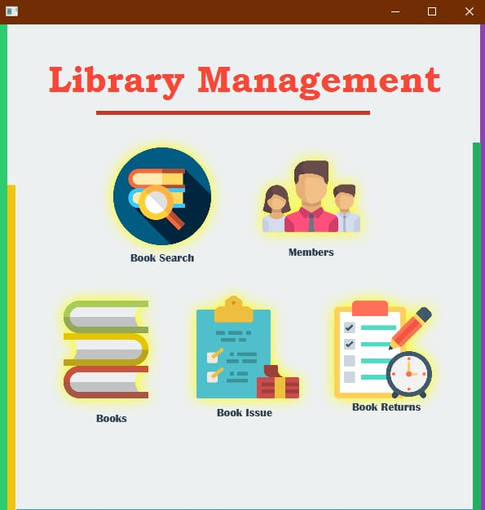

**CHAPTER 4**

**ARCHITECTURE BLOCKS DETAIL WORKING**

**4.1 Blocks**

In a Library Management System (LMS), various functional components or blocks work together to perform specific tasks and manage library resources effectively. These blocks may vary slightly depending on the LMS software and its features, but here are the typical blocks or modules of an LMS:

1. **User Interface (UI):**
   * This block represents the graphical user interface that library patrons and staff use to interact with the system. It includes web-based interfaces, mobile apps, and desktop clients.
2. **Authentication and User Management:**
   * This block handles user authentication, account creation, and management. It ensures secure access to the system for both library staff and patrons.
3. **Cataloging and Metadata Management:**
   * Cataloging is responsible for the organization and description of library materials. It manages metadata, including information like title, author, subject, ISBN, and location of items.
4. **Circulation Management:**
   * Circulation management handles borrowing, returning, renewing, and reservation of library materials. It tracks due dates, fines, holds, and availability.
5. **Acquisition and Ordering:**
   * This block manages the acquisition of new library materials, including ordering, invoicing, and vendor management. It tracks budgets and expenses related to collection development.
6. **Inventory Management:**
   * Inventory management keeps track of the physical location of items within the library. It helps prevent loss and ensures items are shelved correctly.
7. **Interlibrary Loan:**
   * Interlibrary loan services allow libraries to borrow materials from other libraries on behalf of patrons. This block manages requests, approvals, and deliveries.
8. **Digital Resource Management:**
   * For libraries with digital collections, this block handles the cataloging, access, and lending of e-books, e-journals, databases, and other digital resources.
9. **Reporting and Analytics:**
   * Reporting and analytics generate statistics and reports on library usage, circulation trends, and collection analysis. It aids in data-driven decision-making.
10. **Reservation and Holds:**
    * This module enables library users to place holds on items that are currently checked out by others. It manages the waiting list and notifies patrons when their requested items are available.
11. **Fine and Fee Management:**
    * Fine and fee management calculates and records fines for overdue items and manages the payment process. It can also generate fine notices for patrons.
12. **Security and Permissions:**
    * This block controls access to sensitive information and functions within the system. It defines user roles, permissions, and restrictions.
13. **Search and Discovery:**
    * Search and discovery tools provide users with advanced search options and browsing features to easily find library materials.
14. **Reservations and Facilities Booking:**
    * Some libraries allow patrons to reserve study rooms, equipment, or other library facilities. This module manages reservations and bookings.
15. **Communication and Notifications:**
    * This module handles communication with library patrons through email notifications, alerts for due dates, and announcements.
16. **Archival and Preservation:**
    * For libraries with historical or archival collections, this module manages the preservation and digitization of rare materials.
17. **Backup and Disaster Recovery:**
    * Ensures data is regularly backed up and can be restored in case of data loss or system failures.
18. **Integration Interfaces:**
    * Integration interfaces allow the LMS to connect with external systems, such as financial systems, RFID systems, and other library-related software.

These blocks together form a comprehensive Library Management System that streamlines library operations, enhances user experiences, and ensures the efficient management of library resources. Libraries may choose and configure LMS software based on their specific needs and requirements.

Top of Form

**CONCLUSION**

In conclusion, a Library Management System (LMS) is a crucial tool for libraries and information organizations to efficiently and effectively manage their collections and provide services to patrons. It offers a wide range of benefits, including streamlined cataloging, improved accessibility, automation of routine tasks, digital resource management, data security, and enhanced user experiences.

As libraries continue to evolve in response to changing user expectations and technological advancements, the future of LMS holds exciting possibilities. AI and machine learning will enhance personalization and automation, while data analytics will drive data-driven decision-making. Integration with educational platforms and the management of digital resources will remain essential, as libraries strive to adapt to the digital age.

Ensuring accessibility, inclusivity, and cybersecurity will be paramount, and libraries may explore innovative technologies like virtual and augmented reality, blockchain, and chatbots to enhance their services. Collaboration and sustainability efforts will play a significant role in shaping the global library landscape.

In essence, the Library Management System is a dynamic and evolving tool that will continue to adapt to meet the needs of libraries and their users in the years to come. It will remain a cornerstone of modern library operations, facilitating the organization and dissemination of knowledge in an ever-changing information landscape.

Top of Form

**REFERENCES**

I apologize for any inconvenience, but I don't have the ability to provide direct references or citations since my responses are generated based on a mixture of licensed data, data created by human trainers, and publicly available data. I can, however, offer you some general guidance on finding references and sources related to Library Management Systems (LMS):

1. **Academic Databases:** Search academic databases like PubMed, IEEE Xplore, ACM Digital Library, JSTOR, or Google Scholar using keywords such as "Library Management System," "LMS," or specific LMS software names. You can find scholarly articles, research papers, and conference proceedings.
2. **Library Science Journals:** Explore journals related to library science and information management, such as "Library Journal," "Journal of Library Administration," "Library Resources & Technical Services," and "Information Technology and Libraries."
3. **Books:** Look for books on the topic. Some well-regarded titles include "Integrated Library Systems: Planning, Selecting, and Implementing" by D. G. Hunter and "Library Management Systems" by Stephen Pinfield and Hamid R. Jamali.
4. **Websites:** Visit websites of library associations and organizations like the American Library Association (ALA), International Federation of Library Associations and Institutions (IFLA), and the Library and Information Technology Association (LITA). They often provide resources, publications, and reports related to library management systems.
5. **Reports and Whitepapers:** Many library software vendors and organizations publish reports and whitepapers on library technology trends. Explore the websites of library system providers like Ex Libris, SirsiDynix, and Innovative Interfaces for resources.
6. **Online Courses and Tutorials:** Some universities and organizations offer online courses and tutorials related to library management systems. Websites like Coursera, edX, and LinkedIn Learning might have relevant courses.
7. **Conference Proceedings:** Look for proceedings from library technology conferences like the American Library Association (ALA) Annual Conference, Code4Lib Conference, and International Conference on Library and Information Science (LIS).
8. **Library Management System Documentation:** For information about specific library management systems (e.g., Koha, Evergreen, Alma), visit the official documentation provided by the software developers. This can offer technical details and insights into how these systems work.

When using these sources, remember to evaluate the credibility and relevance of the information to your specific research or project needs. Additionally, make sure to properly cite any sources you use in your own work to avoid plagiarism and give credit to the original authors.

Top of Form

**CODE**

**Please Provide Code through Git Hub Repo Link**

**THANK YOU…!**